**Decoding Coded SDA Data** (decode_SDA_data.py)

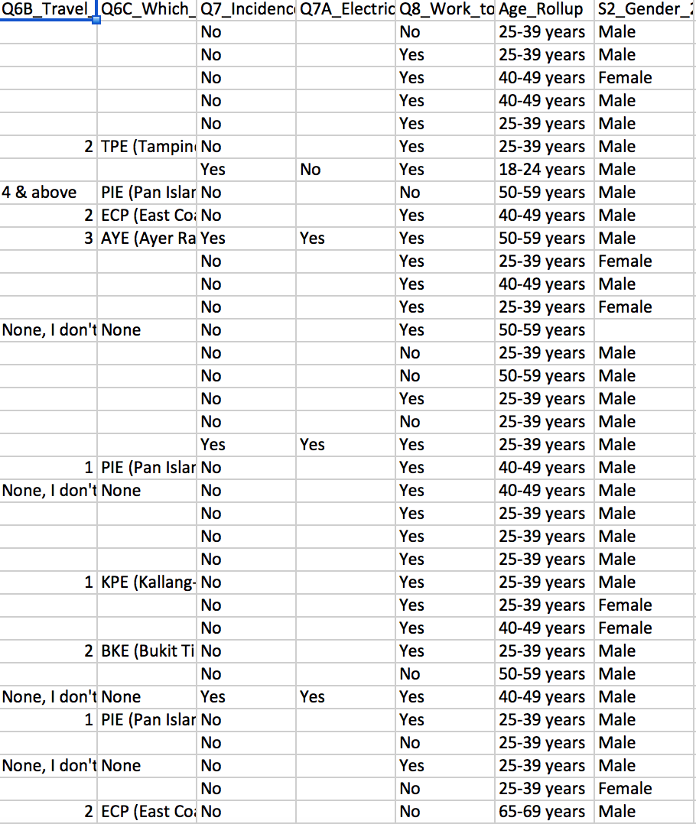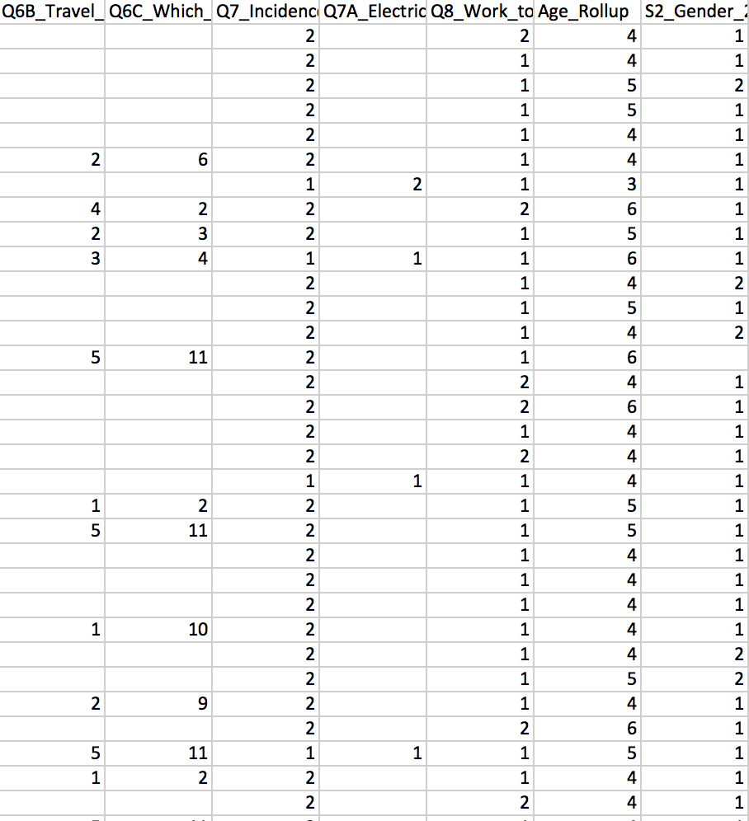

$ python3 decode_SDA_data.py –h

-> This will prompt you on what is needed as input.

$ python3 decode_SDA_data.py SDA_coded_data.csv SDA_codes.csv new_file_name.csv

SDA_coded_data.csv: name of the SDA coded dataset (.csv)

SDA_codes.csv: SDA code file matched to values (.csv)

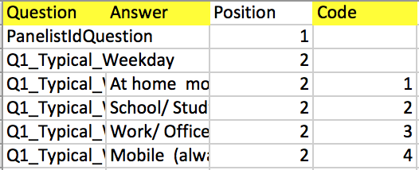Format of data

* 1st column: Question (must match header in SDA coded dataset)
* 2nd column: Answer
* 4th column: Code

new_file_name.csv: New file name for the decoded SDA data to be saved in

**-**

After decoding the data, it is now ready to be input into pre-validation.py.

**Pre-validation** (pre-validation.py)

**Loading & Parsing of SDA data**

$ python3.5 pre-validation.py SDA_data.csv

Output:

Removing any rows with NULL primary key (in column 'S8_phone_numbers_1')...

8 row(s) removed.

Validity Check: Input data is valid.

(validity check according to formats specified in input_format_specifications.txt)

**Transform Address Data into Lat-Longs (Optional Task 1)**

**- Example:**

Please select an optional task (1, 2 or 3):

1. Transform Address Data into Lat-Longs

2. Grouping of categories

3. Filter

Press 0 to skip. 1

Please specify columns for:

1) building info/addresses

2) districts (if any) 🡪 district helps to source postcodes from text addresses more accurately. It is optional to input a district column.

Q1_Typical_Weekday

Q2_Profile

Q2A_Regular_Employee_Business_Owner

Q2B_Office_or_mobile

Q2C_District

Q2D_Building_information

Q4_Primary_mode_of_transport_0_Bus

Q4_Primary_mode_of_transport_0_MRT

Q4_Primary_mode_of_transport_0_CarMotorbike

Q4_Primary_mode_of_transport_0_Taxi

Q4B1_MRT_station_start

Q4B2_MRT_station_alighting_at

Q5B_Bus_number

Q6C_Which_major_expressway

Age_Rollup

S2_Gender_2

S3_Postcode

S8_phone_numbers_1

Or press 0 to exit transform-address-data function. Q2D_Building_information Q2C_District

Remove rows with blanks, NAs and NILs in Q2D_Building_information column? (y/n)

Or press 0 to exit transform-address-data function. y

3 row(s) removed.

Converting textual building info/addresses into postal codes, as derived from google.com...

http://www.google.com/search?q=MoM+Chinatown+singapore+building+address

http://www.google.com/search?q=MoM+Chinatown+singapore+building

………

……

…

For rows where no postcodes were found, or where multiple postcodes were found: refer to 'No_Single_Postcode_Found.csv'. User may manually match text addresses to postcodes and upload file back into program to continue data processing.

⬇

Example data of No_Single_Postcode_Found.csv:

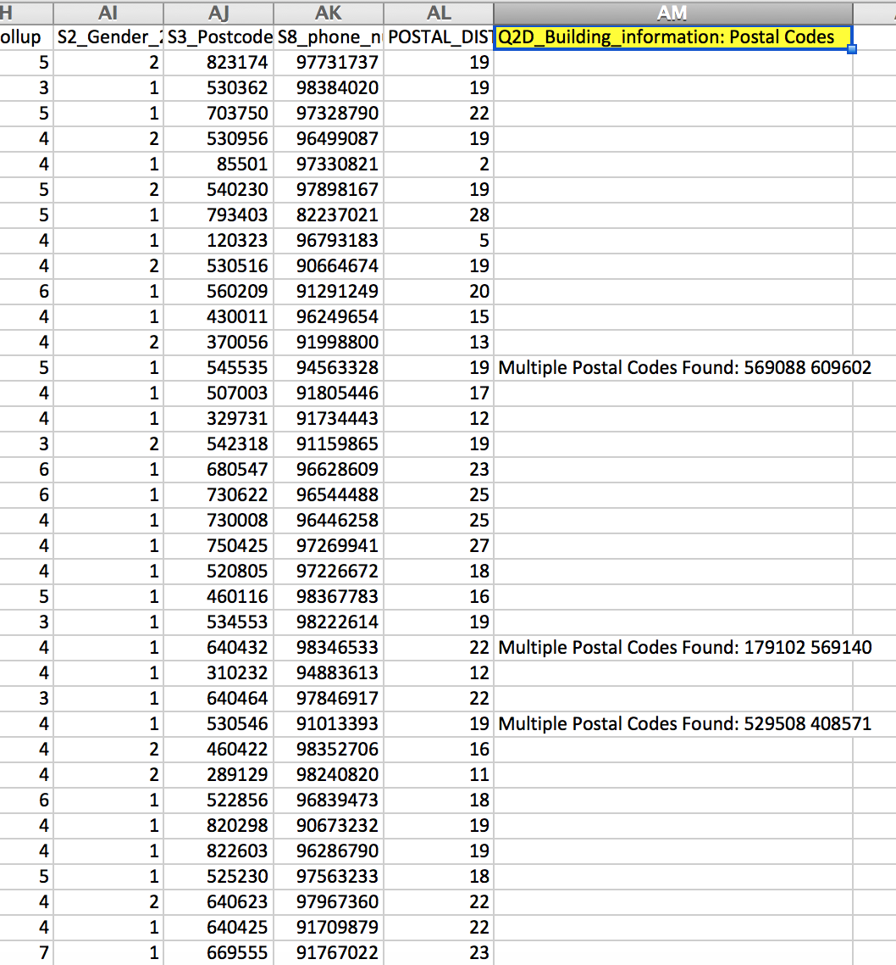

Would you like to input any manually matched rows back into dataset? (y/n)y

Enter the name of the file (.csv) which you would like to combine with the rest of the postal code data. File must be in the same directory as program. (Program assumes that postal codes are in the last column of dataset, and that column headings are included.)No_Single_Postcode_Found.csv

⬇

Here, the user modified the No_Single_Postcode_Found.csv file that was output by the program; changes were saved under the same file name and file was input back into the program.

Example of No_Single_Postcode_Found.csv with manually added postcodes:

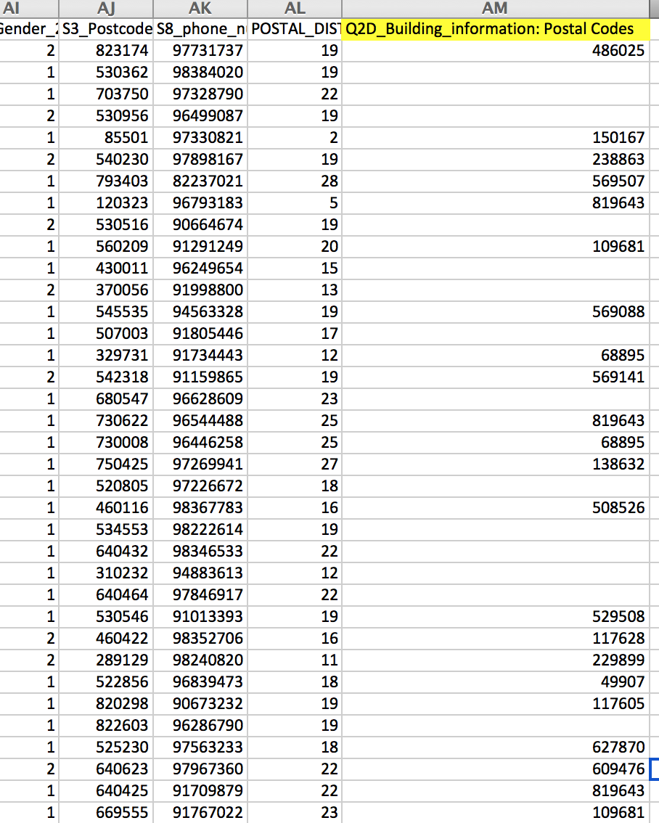

All rows (original postcode rows, text-to-postcode converted rows, and manually converted rows if any) have been combined.

Deriving latitudes and longitudes for all postcodes...

(Rows with blanks, NAs, NILs and erroneous postcodes in the address column will return empty cells for lat-long)

**Grouping of Categories (Optional Task 2)**

Please select an optional task (1, 2 or 3):

1. Transform Address Data into Lat-Longs

2. Grouping of categories

3. Filter

Press 0 to skip. 2

**(a) Applying Grouping on a Single Column**

Please specify column(s) to apply grouping on:

Q1_Typical_Weekday

Q2_Profile

Q2A_Regular_Employee_Business_Owner

Q2B_Office_or_mobile

Q2C_District

Q2D_Building_information

Q4_Primary_mode_of_transport_0_Bus

Q4_Primary_mode_of_transport_0_MRT

Q4_Primary_mode_of_transport_0_CarMotorbike

Q4_Primary_mode_of_transport_0_Taxi

Q4B1_MRT_station_start

Q4B2_MRT_station_alighting_at

Q5B_Bus_number

Q6C_Which_major_expressway

Age_Rollup

S2_Gender_2

S3_Postcode

S8_phone_numbers_1

Or press 0 to exit grouping function. Age_Rollup

Please specify categories to group.

25-39 years

40-49 years

18-24 years

50-59 years

65-69 years

60-64 years

"60-64 years" "65-69 years” • Enclose a category in quotes if the category name contains whitespace

Please specify a name for the new category (any name besides 0). Or press 0 to exit grouping function 60-69 years

8 rows were renamed under new category name.

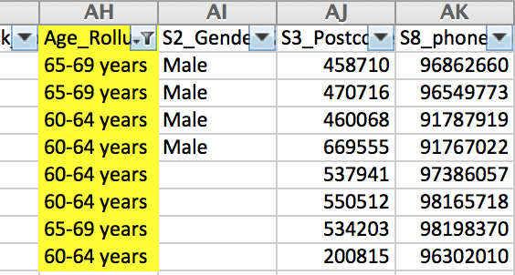

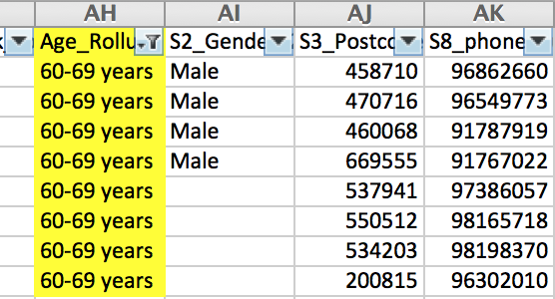

➔

**(b) Applying Grouping on Multiple Columns**

Please specify column(s) to apply grouping on:

Q1_Typical_Weekday

Q2_Profile

Q2A_Regular_Employee_Business_Owner

Q2B_Office_or_mobile

Q2C_District

Q2D_Building_information

Q4_Primary_mode_of_transport_0_Bus

Q4_Primary_mode_of_transport_0_MRT

Q4_Primary_mode_of_transport_0_CarMotorbike

Q4_Primary_mode_of_transport_0_Taxi

Q4B1_MRT_station_start

Q4B2_MRT_station_alighting_at

Q5B_Bus_number

Q6C_Which_major_expressway

Age_Rollup

S2_Gender_2

S3_Postcode

S8_phone_numbers_1

Or press 0 to exit grouping function. Q4_Primary_mode_of_transport_0_CarMotorbike Q4_Primary_mode_of_transport_0_Taxi

Please specify a new category name for records where Columns "Q4_Primary_mode_of_transport_0_CarMotorbike", "Q4_Primary_mode_of_transport_0_Taxi" have values of "0", "0" respectively.

0

Please specify a new category name for records where Columns "Q4_Primary_mode_of_transport_0_CarMotorbike", "Q4_Primary_mode_of_transport_0_Taxi" have values of "Car/ Motorbike", "0" respectively.

Car/ Motorbike

Please specify a new category name for records where Columns "Q4_Primary_mode_of_transport_0_CarMotorbike", "Q4_Primary_mode_of_transport_0_Taxi" have values of "0", "Taxi" respectively.

Taxi

Please specify a new category name for records where Columns "Q4_Primary_mode_of_transport_0_CarMotorbike", "Q4_Primary_mode_of_transport_0_Taxi" have values of "Car/ Motorbike", "Taxi" respectively.

Both

Columns have been combined. Please input a column name for the combined column. Ensure that you do not include whitespace within the column name. Driving_As_Primary_Mode

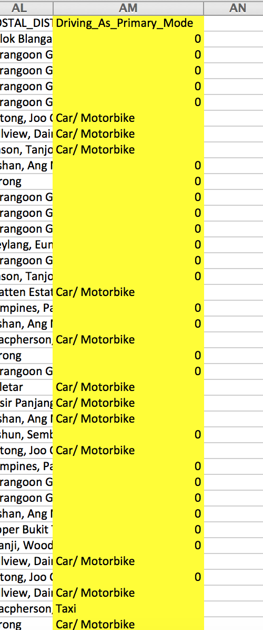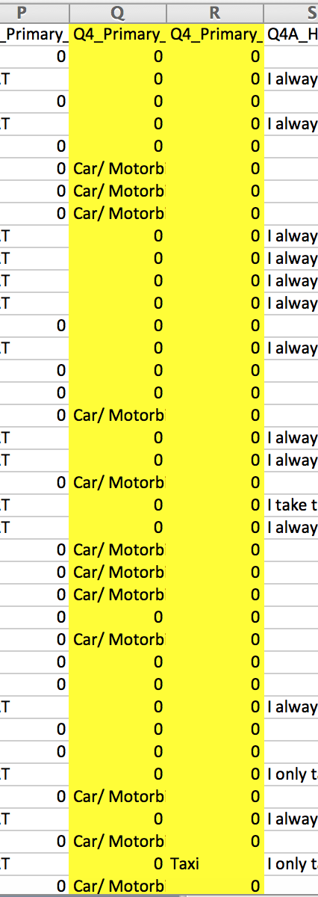

➔

**Filter (Optional Task 3)**

Please select an optional task (1, 2 or 3):

1. Transform Address Data into Lat-Longs

2. Grouping of categories

3. Filter

Press 0 to skip. 3

1. **Exclude blanks, NAs and NILs**

Please select a filter option:

1. Exclude blanks, NAs and NILs

2. Filter based on categories

Press 0 to exit filter function. 1

Please specify a column to filter out blanks, NAs and NILs from:

Q1_Typical_Weekday

Q2_Profile

Q2A_Regular_Employee_Business_Owner

Q2B_Office_or_mobile

Q2C_District

Q2D_Building_information

Q4_Primary_mode_of_transport_0_Bus

Q4_Primary_mode_of_transport_0_MRT

Q4_Primary_mode_of_transport_0_CarMotorbike

Q4_Primary_mode_of_transport_0_Taxi

Q4B1_MRT_station_start

Q4B2_MRT_station_alighting_at

Q5B_Bus_number

Q6C_Which_major_expressway

Age_Rollup

S2_Gender_2

S3_Postcode

S8_phone_numbers_1

Press 0 to exit filter function. Q4B1_MRT_station_start

205 row(s) removed.

1. **Filter based on categories**

Please select a filter option:

1. Exclude blanks, NAs and NILs

2. Filter based on categories

Press 0 to exit filter function. 2

1. **1 column specified; Include specific categories**

Please specify column(s) to apply categorical filter on:

Q1_Typical_Weekday

Q2_Profile

Q2A_Regular_Employee_Business_Owner

Q2B_Office_or_mobile

Q2C_District

Q2D_Building_information

Q4_Primary_mode_of_transport_0_Bus

Q4_Primary_mode_of_transport_0_MRT

Q4_Primary_mode_of_transport_0_CarMotorbike

Q4_Primary_mode_of_transport_0_Taxi

Q4B1_MRT_station_start

Q4B2_MRT_station_alighting_at

Q5B_Bus_number

Q6C_Which_major_expressway

Age_Rollup

S2_Gender_2

S3_Postcode

S8_phone_numbers_1

Press 0 to exit filter function. Q2C_District

1. Include specific categories or 2. Exclude specific categories? 1

Key in the category(s) by row: (Press 0 to exit filter function) Chinatown;"Changi Airport";"Buona Vista"

375 row(s) removed. ⬇

Only rows with “Chinatown” OR “Changi Airport” OR “Buona Vista” in the Q2C_District column are included in the dataset.

After applying filter:

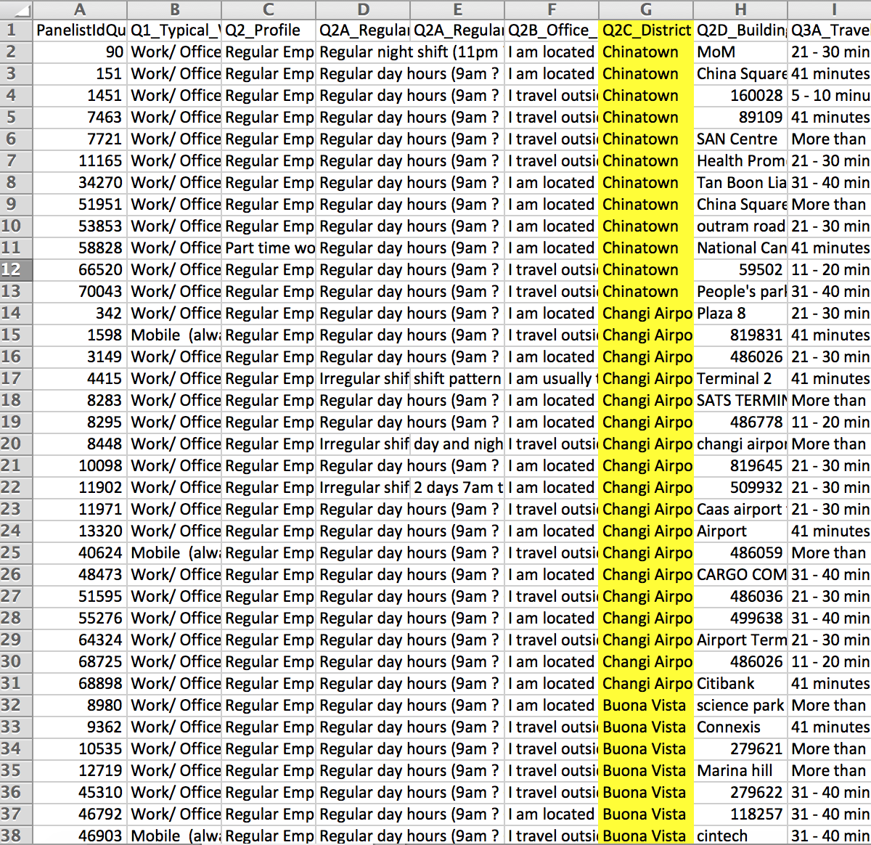

**(ii) Multiple columns specified; Include specific categories**

Please specify column(s) to apply categorical filter on:

Q1_Typical_Weekday

Q2_Profile

Q2A_Regular_Employee_Business_Owner

Q2B_Office_or_mobile

Q2C_District

Q2D_Building_information

Q4_Primary_mode_of_transport_0_Bus

Q4_Primary_mode_of_transport_0_MRT

Q4_Primary_mode_of_transport_0_CarMotorbike

Q4_Primary_mode_of_transport_0_Taxi

Q4B1_MRT_station_start

Q4B2_MRT_station_alighting_at

Q5B_Bus_number

Q6C_Which_major_expressway

Age_Rollup

S2_Gender_2

S3_Postcode

S8_phone_numbers_1

Press 0 to exit filter function. Q1_Typical_Weekday Q2B_Office_or_mobile

1. Include specific categories or 2. Exclude specific categories? 1

Key in the category(s) by row: (Press 0 to exit filter function) "Work/ Office" "I am located in the office most of the time";"Mobile (always on the move, travelling to different areas)" "I am usually travelling outside of the office for work / on the road"

112 row(s) removed.  ⬇

A row is included if:

* It contains “Work/ Office” in Q1_Typical_Weekday column AND “I am located in the office most of the time” in Q2B_Office_or_mobile column

OR

* It contains “Mobile (always on the move, travelling to different areas)" in Q1_Typical_Weekday column AND “I am usually travelling outside of the office for work / on the road” in Q2B_Office_or_mobile column

* AND: delimited by space
* OR: delimited by “;”

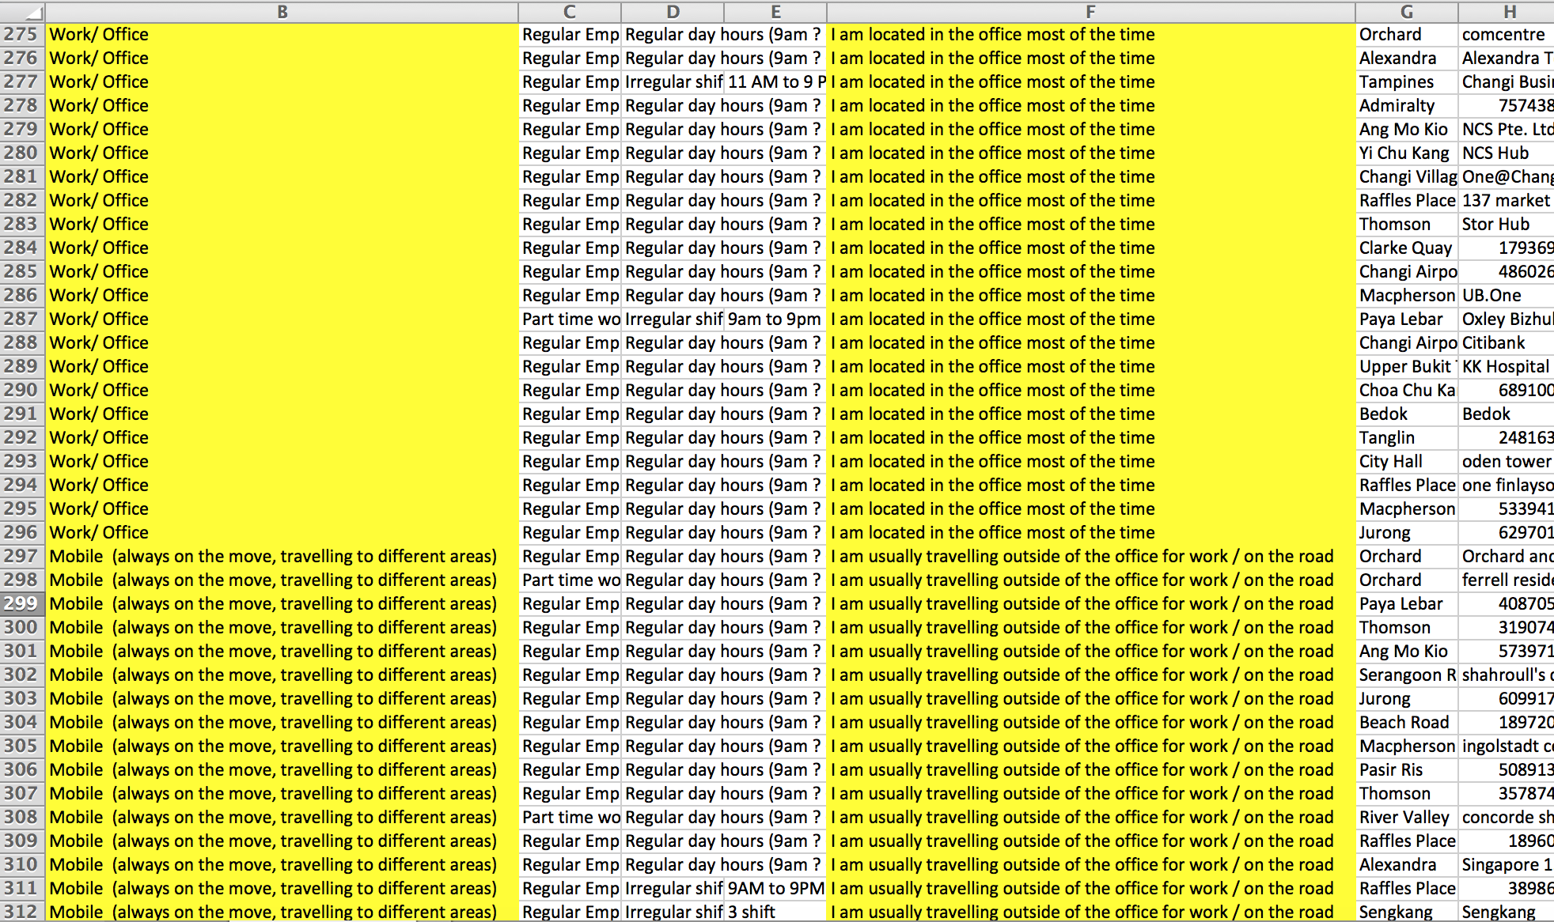After applying filter:

**(iii) 1 column specified; Exclude specific categories**

Please specify column(s) to apply categorical filter on:

Q1_Typical_Weekday

Q2_Profile

Q2A_Regular_Employee_Business_Owner

Q2B_Office_or_mobile

Q2C_District

Q2D_Building_information

Q4_Primary_mode_of_transport_0_Bus

Q4_Primary_mode_of_transport_0_MRT

Q4_Primary_mode_of_transport_0_CarMotorbike

Q4_Primary_mode_of_transport_0_Taxi

Q4B1_MRT_station_start

Q4B2_MRT_station_alighting_at

Q5B_Bus_number

Q6C_Which_major_expressway

Age_Rollup

S2_Gender_2

S3_Postcode

S8_phone_numbers_1

Press 0 to exit filter function. Age_Rollup

1. Include specific categories or 2. Exclude specific categories? 2

Key in the category(s) by row: (Press 0 to exit filter function) "50-59 years";"40-49 years"

132 row(s) removed. ⬇

Rows with “50-59 years” OR “40-49 years” in the Age_Rollup column are excluded from the dataset.

**(iv) Multiple columns specified; Exclude specific categories**

Please specify column(s) to apply categorical filter on:

Q1_Typical_Weekday

Q2_Profile

Q2A_Regular_Employee_Business_Owner

Q2B_Office_or_mobile

Q2C_District

Q2D_Building_information

Q4_Primary_mode_of_transport_0_Bus

Q4_Primary_mode_of_transport_0_MRT

Q4_Primary_mode_of_transport_0_CarMotorbike

Q4_Primary_mode_of_transport_0_Taxi

Q4B1_MRT_station_start

Q4B2_MRT_station_alighting_at

Q5B_Bus_number

Q6C_Which_major_expressway

Age_Rollup

S2_Gender_2

S3_Postcode

S8_phone_numbers_1

Press 0 to exit filter function. Q4_Primary_mode_of_transport_0_Bus Q4_Primary_mode_of_transport_0_MRT

1. Include specific categories or 2. Exclude specific categories? 2

Key in the category(s) by row: (Press 0 to exit filter function) Bus MRT;0 0

228 row(s) removed.  ⬇

A row is excluded if:

* It contains “Bus” in Q4_Primary_mode_of_transport_0_Bus column AND “MRT” in Q4_Primary_mode_of_transport_0_MRT column

OR

* It contains “0” in Q4_Primary_mode_of_transport_0_Bus column AND “0” in Q4_Primary_mode_of_transport_0_MRT column

**Mapping MSISDN/IMSIs and outputting final manipulated SDA dataset**

Please select an optional task (1, 2 or 3):

1. Transform Address Data into Lat-Longs

2. Grouping of categories

3. Filter

Press 0 to skip. 0

All the remaining rows in this dataset will be used to validate the algorithm output.

Enter the name of the encrypted MSISDN/IMSI file (.csv). File must be in the same directory as program. (Primary key in 1st column, Encrypted MSISDN/IMSI in 2nd column. Column headings are to be included) MSISDN_mapping_table.csv

⬇

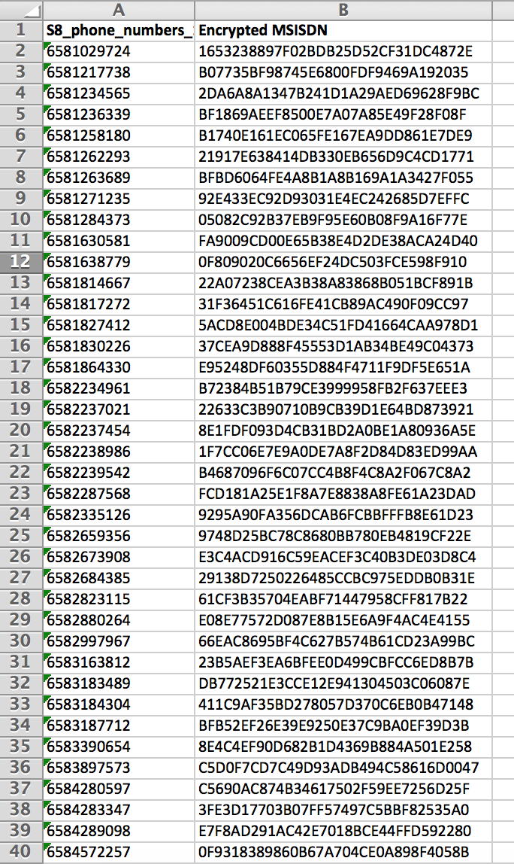

Example of MSISDN/IMSI file

1st column – phone numbers beginning with 65

2nd column – MSISDN/IMSI

Program is now matching encrypted MSISDNs or IMSIs to primary key of each row...

Matching completed. Final SDA validation data stored in 'final_SDA_data.csv', format of final data stored in ‘SDA_data_format.csv’.

Pre-validation data processing is completed.